Arten der Kinderwunschbehandlung
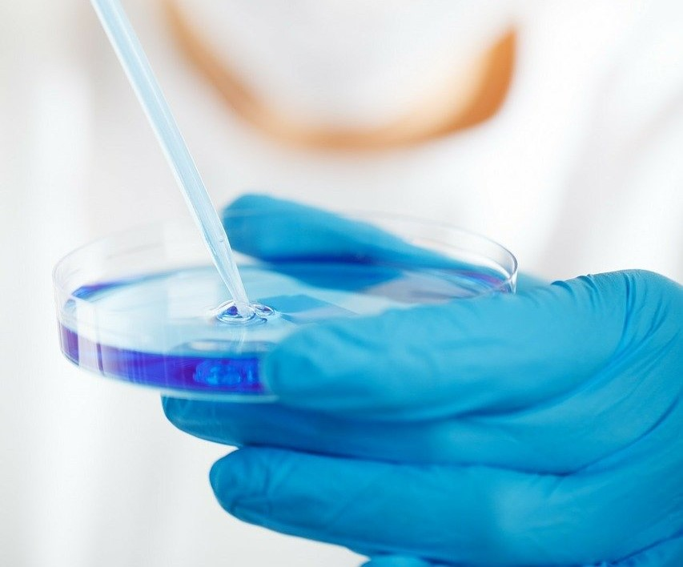
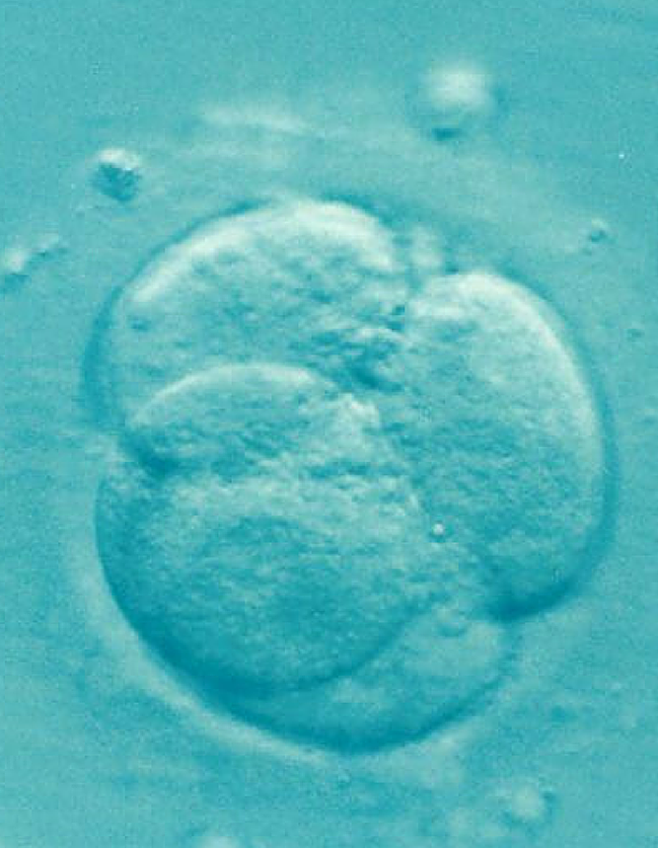

Fertility treatment is not just fertility treatment. Depending on what the conditions are for a couple, the type of fertility treatment is decided. In the following you will find out what IUI, IVF and ICSI are all about.

Intrauterine Insemination (IUI)
In intrauterine insemination, a prepared sperm sample from her partner (or a donor) is transferred to the uterus on the day of ovulation. Processing the sperm usually improves the mobility and density of the sperm. In intrauterine insemination, low-dose hormonal stimulation of the ovary can be used.

In Vitro Fertilization (IVF)
With in-vitro fertilization, a higher dose of hormonal stimulation is used so that several follicles mature at the same time. After ovulation, the egg vesicles that have formed are removed from the woman's ovary through the vagina. On the same day, fertilization takes place between the man's sperm and the woman's egg cells. To do this, the mobile sperm are grouped around the egg cell in a test tube. The very next day you can see how many eggs could be fertilized. At this stage, some of the fertilized egg cells can also be frozen (see cryopreservation). The embryos or blastocysts that have developed from the egg cells are transferred back without anesthesia between three and five days after the egg vesicles have been removed.

Intracytoplasmic Sperm Injection (ICSI)
The intracytoplasmic sperm injection is considered to be an advanced in vitro fertilization. The procedure is similar to that of an IVF. The only difference is in the fertilization of the eggs. With ICSI, an optimal sperm per individual cell is brought into the egg cell using a microscope.

Additional treatments
In some men, sperm cannot be obtained through masturbation. In this case a TESE or MESA is carried out. The TESE is testicular sperm extraction, where the sperm is surgically removed from the testicle. The MESE is the micro-surgical epidimensional sperm aspiration, where the sperm is surgically obtained from the epididymis.

With cryopreservation, egg cells are stored in the so-called pronuclear stage in a depot with liquid nitrogen at almost -200 degrees Celsius. This allows the egg cells to be stored for several years without damaging them.

The time-lapse incubator is a procedure in IVF and ICSI. Using an integrated video camera, the time-lapse incubator constantly monitors the development of the embryo without disturbing it. That can increase the chances of success.

